
Software Engineering Department
Braude College of Engineering
Final Project – Phase A (61998)

Network Stability using Hyperbolic Geometric latent diffusion model
26-2-R-5

By:
Rotem Maravent
Irit Kogan

Advisors:
Dr. Renata Avros
Prof. Zeev Volkovich

Link to GitHub

Table of Contents
.1 Introduction 2
2. Mathematical Background 3
2.1. Mathematical Foundation of Graphs and Latent Space 3
2.1.1. Graph Topology and Matrix Representations 3
2.1.2. Classical Stability Metrics and their Limitations 3
2.1.3. Euclidean Limitations and the Anisotropy Problem 4
2.2. Hyperbolic Geometry in Network Science 4
2.2.1. Riemannian Manifolds and the Hyperboloid Model 4
2.2.2. The Popularity-Similarity (PSO) Framework 5
2.3. Denoising Diffusion Probabilistic Models 6
2.3.1. The Forward Diffusion Process in Discrete Time 6
2.3.2. The Reverse Denoising Process 6
2.3.3. DDPM Objective Function 6
2.4. HypDiff Framework and Geometric Measures 7
2.4.1. Hyperbolic Geometric Autoencoding 7
2.4.2. Anisotropic Diffusion with Geometric Constraints 8
2.4.3. Hyperbolic Variance and the Fréchet Mean 9
3. Proposed Methodology 10
3.1. System Overview and Architecture 10
3.2. Graph Perturbation Module 11
3.3. Generative Recovery Module 11
3.4. Probabilistic Stability Scoring Module 12
4. Evaluation and Verification Plan 13
4.1. Success Metrics and Criteria 13
4.2. Evaluation Datasets 13
4.2.1. Synthetic Datasets 13
4.2.2. Real-World Datasets 14
4.3. Planned Experiments and Expected Results 14
4.4. Formal Software Testing Strategy 15
4.5. Diffusion Efficiency Analysis 16
5. System Infrastructure and Project Roadmap 17
5.1. System Requirements 17
5.2. Expected Challenges 17
5.3. Future Work Plan and Project Roadmap 18
5.4. Ai Tools Usage 19

Abstract
Evaluating complex network resilience is critical across critical infrastructures, biological systems, and social structures. However, classical graph-theoretic metrics assess networks as deterministic, fixed topologies, completely ignoring structural uncertainty under dynamic stress. While deep learning alternatives like Graph Neural Networks (GNNs) attempt to model these graphs, they introduce severe geometric distortion by forcing non-Euclidean structures into flat Euclidean spaces, while standard isotropic diffusion models destroy delicate topological information. To address these limitations, this project proposes a novel network stability evaluation framework by adapting the state-of-the-art Hyperbolic Geometric Latent Diffusion Model (HypDiff). By leveraging continuous hyperbolic geometry, the framework naturally captures hierarchical scale-free topologies without distortion. The proposed architecture systematically applies controlled edge disruptions, maps the damaged graphs into a hyperbolic latent space, and utilizes an anisotropic reverse denoising process to probabilistically reconstruct missing links. Finally, a dedicated scoring module aggregates recovery frequencies to calculate a dynamic, uncertainty-aware stability score $(S_{stability})$. The framework will be validated on synthetic models (SBM, BA) and real-world benchmarks (IMDB-B, PROTEINS) to provide a precise, geometry-derived tool for quantifying structural robustness.

Introduction
Complex networks appear in many real-world domains, spanning from essential infrastructures such as power grids and communication lines to biological maps of protein interactions and social networks. In practice, these topologies are rarely static and remain constantly exposed to environmental stress, dynamic loads, or targeted structural failures (Artime et al., 2024). Classical approaches to evaluating the resilience and stability of these complex systems have relied on classical graph theoretic metrics like algebraic connectivity, betweenness centrality and effective resistance (Artime et al., 2024; Ellens & Kooij, 2013). Although these traditional tools are informative, they suffer from a severe conceptual flaw by treating each network as a single, fixed point in a continuous representation space. This deterministic assumption completely ignores structural uncertainty, failing to account for the multiple probabilistic states a network can occupy under stress. Consequently, a stability evaluation tool incapable of representing structural uncertainty cannot provide a reliable assessment of true system resilience.
Aattempting to capture this intricate topology using modern deep learning approaches, such as Graph Neural Networks, presents a critical bottleneck. Traditionally, these models force complex, non-Euclidean graph structures into flat Euclidean latent spaces, which inherently cause massive geometric distortion (Chami et al., 2019). Furthermore, applying standard generative diffusion models to these distorted embeddings ultimately destroys the network's delicate structural information, fundamentally preventing accurate measurements of true stability under perturbation (Fu et al., 2024; Yang et al., 2023).
To address these geometric challenges, recent research demonstrates that hyperbolic space naturally models hierarchical structures without distortion. Concurrently, generative diffusion models, such as GDSS and DiGress, have proven highly effective for learning probabilistic graph representations by treating graphs as distributions rather than single points (Jo et al., 2022; Vignac et al., 2022). Combining these two paradigms, the state-of-the-art HypDiff model (Fu et al., 2024) established a latent diffusion framework operating within hyperbolic space. However, HypDiff was engineered strictly for graph generation. Applying such probabilistic models to measure network stability remains an unresolved research direction. Specifically, connecting continuous geometry to structural resilience is a major open challenge (Artime et al., 2024). This project bridges this gap by adapting the HypDiff framework to measure stability, representing networks as distributions over potential structural states.
This project proposes a network stability evaluation framework based on a Hyperbolic Geometric Latent Diffusion Model. The architecture applies controlled edge disruptions, maps the damaged graph into a hyperbolic latent space, and utilizes an anisotropic reverse denoising process to probabilistically reconstruct missing links. Finally, a scoring module calculates a dynamic stability score based on the recovery frequency of removed edges, providing a precise, geometry derived tool to quantify structural robustness.

Mathematical Background

Mathematical Foundation of Graphs and Latent Space

Graph Topology and Matrix Representations
A complex network is mathematically abstracted as a graph $G=(V,E)$, where $V$is the set of nodes and $E$ is the set of edges representing their interactions (Ellens & Kooij, 2013). The network's topology is represented by an $n×n$ adjacency matrix $A$, where $A_{ij}=1$ if an edge connects nodes $i$ and $j$, and $A_{ij}=0$otherwise.
Node connectivity is quantified by its degree $k_{i}$, representing its total number of links (Artime et al., 2024). These degrees form the diagonal degree matrix $D$, where $D_{ii}=k_{i}$.
Finally, the graph Laplacian $L$, defined as $L=D-A$ (Ellens & Kooij, 2013), is a crucial matrix representation. Its spectral properties are foundational in geometric machine learning for defining structural filters and formulating continuous-time diffusion processes (Elhag et al., 2022).

Classical Stability Metrics and their Limitations
Traditionally, network robustness is evaluated using deterministic topological metrics that quantify a network's vulnerability to failures or attacks (Ellens & Kooij, 2013). Common spectral and spatial measures include Algebraic Connectivity (the second smallest eigenvalue of the Laplacian matrix, $λ_{2}$), which reflects how easily a graph can be disconnected, and Betweenness Centrality, which identifies structural bottlenecks based on the fraction of shortest paths passing through a specific node or edge (Ellens & Kooij, 2013).
Despite their utility in classical network science, these metrics suffer from a fundamental limitation: they evaluate networks as deterministic, fixed topologies. By assuming the network is a fixed point, classical metrics are unable to capture structural uncertainty or represent the probabilistic nature of networks operating under dynamic stress (Artime et al., 2024). This deterministic bottleneck necessitates a shift toward probabilistic, generative frameworks to properly evaluate true network stability.

Euclidean Limitations and the Anisotropy Problem
Graph Neural Networks (GNNs) traditionally embed nodes into Euclidean space. However, real world networks frequently exhibit hierarchical and scale free topologies where the graph volume grows exponentially. Embedding these complex structures into a Euclidean space, which only grows polynomially with respect to the radius, inherently incurs massive geometric distortion (Chami et al., 2019).
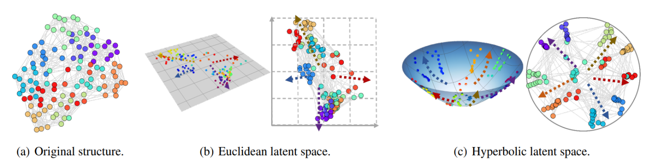
Furthermore, graph representations in Euclidean latent space suffer from the anisotropy problem. Unlike regular grid like data (such as images) that distribute isotropically around the origin, non-Euclidean graph embeddings are highly anisotropic, concentrating heavily along specific directional axes (Fu et al., 2024). Consequently, applying standard continuous time diffusion models which rely on injecting isotropic Gaussian noise is fundamentally flawed for graphs.
Figure 1. Visualization of NCAA football graph embeddings via SVD demonstrating the anisotropy problem. The figure shows the original structure (a) compared against its 2D Euclidean projection (b) and 2D hyperbolic Poincaré disk projection (c) (Fu et al., 2024).
Isotropic noise cannot distinguish the anisotropic structural signal from random noise, causing the signal to noise ratio (SNR) to decline rapidly towards zero (Yang et al., 2023). Ultimately, this isotropic diffusion treats the anisotropic structural information as noise, destroying the underlying topological information upon which true network stability analysis depends (Fu et al., 2024; Yang et al., 2023).

Hyperbolic Geometry in Network Science

Riemannian Manifolds and the Hyperboloid Model
Hyperbolic geometry is a non-Euclidean geometry characterized by a constant negative curvature, making it naturally equipped to model continuous hierarchical structures (Nickel & Kiela, 2017). Among its isometric models, the hyperboloid model (also known as the Lorentz model) is highly preferred in graph machine learning due to its rigorous numerical stability (Chami et al., 2019). Given two points $x$ and $y$, the Minkowski inner product is mathematically defined as:
$${\left\langle x,y\right\rangle }_{L}=-x_{0}y_{0}+\sum_{i=1}^{d}{x_{i}y_{i}},$$
the $d$ dimensional hyperboloid manifold $H^{d,K}$ with constant negative curvature $-1/K$ (where $K>0$) is mathematically defined as the set of points $x∈R^{d+1}$ satisfying the conditions:
${\left\langle x,x\right\rangle }_{L}=-K$ , $x_{0}>0 .$
Since hyperbolic space lacks a standard vector space structure, geometric operations are fundamentally performed in the Euclidean tangent space $T_{x}H^{d,K}$, which provides a local approximation of the manifold at point $x$. The mapping between the hyperbolic manifold and this Euclidean tangent space is achieved through two bijective operations: the logarithmic map ${logmap}_{x}^{K}(y)$ projects a point $y$ from the manifold onto the tangent space, while the exponential map ${expmap}_{x}^{K}(v)$ projects a tangent vector $v$ back onto the hyperboloid manifold (Chami et al., 2019). These maps establish the required mathematical foundation to perform diffusion processes directly within the hyperbolic space.

The Popularity-Similarity (PSO) Framework
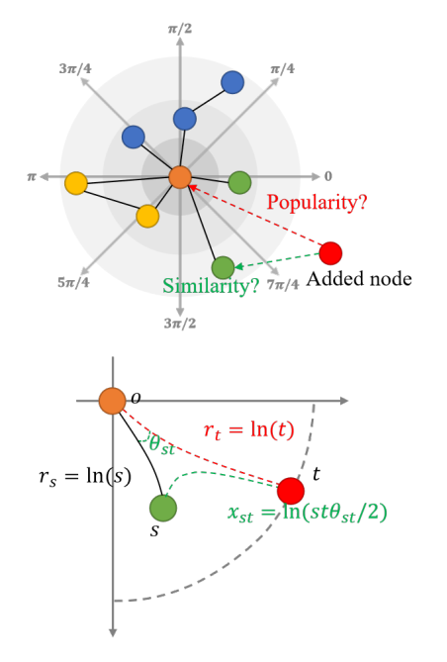

The Popularity Similarity optimization framework provides a geometric interpretation of complex network topologies by mapping nodes into a polar coordinate system within the hyperbolic space. In this latent space, the radial coordinate $r$ represents the popularity of a node. Nodes located closer to the origin possess higher popularity and consequently attract more connections. Conversely, the angular coordinate $θ$ abstracts the structural similarity between nodes, dictating local clustering and community formations (Papadopoulos et al., 2012).
Figure 2. Illustration of the Popularity-Similarity Optimization (PSO) framework within hyperbolic space. The diagram demonstrates how a node's radial coordinate corresponds to its popularity, while the angular coordinate reflects structural similarity (Fu et al., 2024).

The hyperbolic distance between two nodes $s$ and $t$, possessing polar coordinates $\left(r_{s},θ_{s}\right)$ and $\left(r_{t},θ_{t}\right)$, acts as a unified metric combining both attractiveness attributes. This distance is mathematically approximated as:
$$x_{st}=r_{s}+r_{t}+\ln\left(\frac{θ_{st}}{2}\right),$$
where $θ_{st}$ represents the angular distance between the two nodes (Papadopoulos et al., 2012). The framework demonstrates that complex networks naturally grow by minimizing this distance, thereby establishing connections that optimally balance global popularity and local similarity.

Denoising Diffusion Probabilistic Models

The Forward Diffusion Process in Discrete Time
Denoising Diffusion Probabilistic Models operate by gradually perturbing an initial data distribution with Gaussian noise over a sequence of discrete time steps $t∈\{1,…,T\}$ (Ho et al., 2020). Given an initial data representation $x_{0}$, the forward diffusion process is mathematically defined as a Markov chain that progressively injects noise according to a predefined variance schedule $β_{t}$. The transition probability at each discrete step is formulated as:
$$q(x_{t}∣x_{t-1})=N(x_{t};\sqrt{1-β_{t}}x_{t-1},β_{t}I),$$
where $N$denotes the normal distribution and $I$ represents the identity matrix. By defining $α_{t}=1-β_{t}$ and ${\overline{α}}_{t}=\prod_{i=1}^{t}{α_{i}}$, the Markovian property allows for direct sampling of the noisy state at any arbitrary time step $t$ using the closed form equation:
$$q(x_{t}∣x_{0})=N(x_{t};\sqrt{{\overline{α}}_{t}}x_{0},(1-{\overline{α}}_{t})I).$$
As the time step $t$ approaches the maximum limit $T$, the original structural signal is completely transformed into an isotropic Gaussian noise distribution, providing a tractable prior for the generative reconstruction (Huang et al., 2022).

The Reverse Denoising Process
To generate new data, the model must reverse the forward perturbation by gradually removing the noise. Since the exact reverse transition probability is computationally intractable, Denoising Diffusion Probabilistic Models employ a neural network with learnable parameters $θ$ to approximate this reverse time Markov chain (Ho et al., 2020). The approximated reverse process is mathematically defined as:
$$p_{θ}(x_{t-1}∣x_{t})=N(x_{t-1};μ_{θ}(x_{t},t),Σ_{θ}(x_{t},t)),$$
where $μ_{θ}$ and $Σ_{θ}$ represent the predicted mean and covariance matrices computed by the network at a specific time step t. In practical implementations, especially those adapted for complex topological structures like graphs, the denoising network often directly predicts the original clean data $x_{0}$ instead of estimating the intermediate noise parameters (Yang et al., 2023). By recursively applying this learned reverse transition starting from pure isotropic Gaussian noise at the maximum step $T$, the model progressively reconstructs the geometric structure and generates high fidelity samples out of the initial noise distribution.

DDPM Objective Function
To optimize the neural network parameters $θ$, Denoising Diffusion Probabilistic Models traditionally minimize a variational bound on the negative log likelihood of the data (Ho et al., 2020). This optimization is mathematically equivalent to a denoising score matching objective, which measures the mean squared error between the true added noise and the predicted noise.
However, for complex non-Euclidean structures, recent graph diffusion frameworks directly predict the clean initial state rather than estimating the intermediate noise (Yang et al., 2023). Consequently, the objective function is formulated to minimize the expected Euclidean distance between the original unperturbed feature representation $X_{0}$ and the predicted feature representation computed by the denoising network $f_{θ}$. Given the noisy features $X_{t}$ at a uniformly sampled time step $t$ and the adjacency matrix $A$, the dedicated loss function $L_{HDM}$ (Fu et al., 2024) is formally defined as:
$$L_{HDM}=E_{X_{0},t}[∥f_{θ}\left(X_{t},A,t\right)-X_{0}∥^{2}].$$
By optimizing this objective, the network effectively learns to map the isotropic noise distribution back to the original topological structure, establishing a stable generative engine (Fu et al., 2024).

HypDiff Framework and Geometric Measures

Hyperbolic Geometric Autoencoding
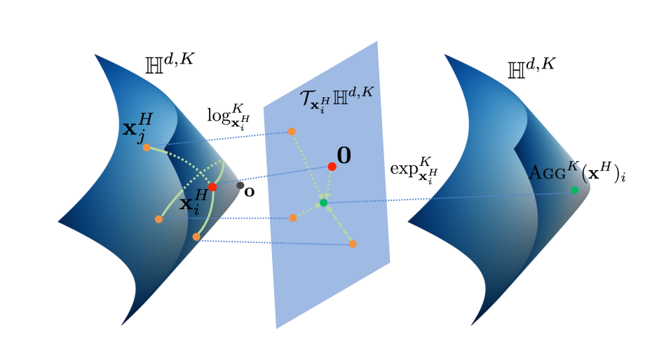
To process discrete graph structures within a continuous domain, the HypDiff framework employs a hyperbolic geometric autoencoder (Fu et al., 2024). This architecture consists of an encoder that embeds the graph into a hyperbolic manifold and a Fermi-Dirac decoder that reconstructs the graph topology. The encoder is implemented as a Hyperbolic Graph Convolutional Neural Network, which utilizes exponential and logarithmic maps to project features between the hyperbolic manifold and its corresponding Euclidean tangent spaces (Chami et al., 2019).
Figure 3. The neighborhood aggregation process in HGCN. Node embeddings are first projected onto the Euclidean tangent space for aggregation via the logarithmic map and subsequently mapped back to the hyperbolic manifold using the exponential map (Chami et al., 2019).

After the graph is embedded and processed within the latent space, the Fermi-Dirac Decoder algorithm calculates the precise probability of edge connections between nodes (Fu et al., 2024; Nickel & Kiela, 2017). It computes these probabilities by converting their continuous hyperbolic distances (utilizing the metric $x_{st}$ defined previously in the PSO framework) into discrete edge probabilities. Mathematically, the probability of an edge existing between node $i$ and node $j$ is computed using the Fermi-Dirac distribution:
$$P(A_{i,j}=1)=\frac{1}{e^{(x_{st}-r)/t}+1},$$
where $r$ and $t$ are hyperparameters controlling the scale and steepness of the activation. This algorithmic step explicitly bridges the continuous latent state and the discrete graph topology to reconstruct the edges. To optimize this embedding process, the framework minimizes a specific reconstruction loss function for the autoencoder. Given the original graph data $x$ and its latent hyperbolic representation $z_{x}$, the autoencoder loss $L_{HAE}$ is mathematically defined as:
$$L_{HAE}=-E_{q_{ϕ}\left(z_{x} ∣ x\right)}[logmap_{o}^{c}p_{ξ}(x∣z_{x})],$$
in this equation $q_{ϕ}$ represents the approximate posterior distribution produced by the hyperbolic encoder with learnable parameters $ϕ$ and $p_{ξ}$ denotes the likelihood distribution modeled by the Fermi-Dirac decoder with learnable parameters $ξ$ (Fu et al., 2024). Furthermore, $logmap_{o}^{c}$ refers to the logarithmic mapping to the north pole origin $o$ of the hyperbolic space. According to Fu et al. (2024), using this specific mapping simplifies the computation by allowing the model to approximate the hyperbolic Gaussian distribution using the Gaussian distribution of the tangent plane.

Anisotropic Diffusion with Geometric Constraints
Standard diffusion models inject isotropic white noise, which rapidly degrades the signal to noise ratio when applied to highly anisotropic non-Euclidean graph embeddings (Yang et al., 2023). To preserve the underlying topology, the framework introduces a directional diffusion approach guided by specific geometric boundaries (Fu et al., 2024).
Instead of uniform noise, the model utilizes an angular similarity constraint to preserve local community structures during the diffusion process (Fu et al., 2024). To accurately apply these constraints, the network nodes must first be grouped into structural communities. As proposed by Fu et al. (2024), the system achieves this during a preprocessing stage by utilizing the Hyperbolic-Kmeans algorithm to cluster the nodes based on their geometric similarity. This clustering process identifies the hyperbolic center for each community, denoted as $h_{μi}$ for a given node $i$. The angular constrained Gaussian noise $z$ is then calculated relative to this specific community center as follows:
$$z=sgn(logmap_{o}^{c}(h_{μi}))*ϵ,$$
where $logmap_{o}^{c}$ is the logarithmic map at the origin $o$, $sgn$ is the sign function, and $ϵ$ represents standard Gaussian noise (Fu et al., 2024).
This directional noise $z$ ensures that the perturbation aligns with the topological clustering of the network. Combined with a radial popularity constraint that regulates the diffusion strength along the radial axis, this anisotropic approach prevents the structural information from being treated as random noise, thereby maintaining the scale free properties of the original graph throughout the latent diffusion process (Fu et al., 2023).
To fully capture the network structural properties during the forward process, the HypDiff model proposed by Fu et al. (2024) integrates both the angular similarity constraints and the radial popularity constraints into a single unified diffusion equation. By combining the angular constrained noise $z$ with a radial growth control mechanism, the complete geometric forward diffusion process is defined as:
$$x_{t}=\sqrt{α_{t}}x_{0}+\sqrt{1-α_{t}}z+δtanh\left[\frac{\sqrt{c}λ_{c}^{o}t}{T_{0}}\right]x_{0},$$
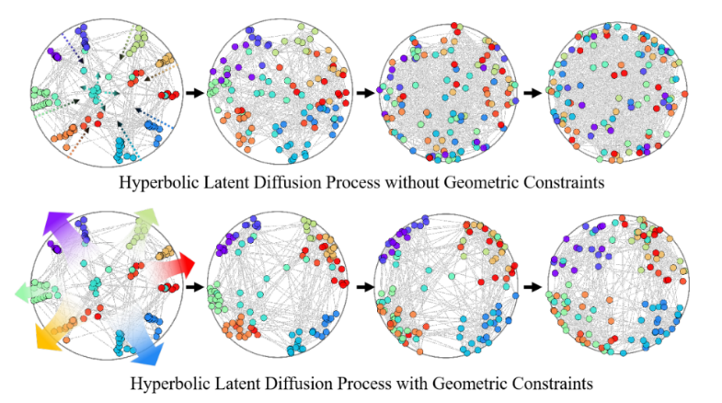
in this final equation, $z$ represents the angular constrained Gaussian noise that preserves community structures, while the trigonometric term acts as the radial constraint. According to Fu et al. (2024), the parameter $δ$ is the radial popularity coefficient, which explicitly controls the diffusion strength of each node in the hyperbolic space. This specific radial constraint ensures that the inherent popularity of central nodes is maintained throughout the diffusion steps, preventing the structural degradation typically caused by standard isotropic noise.
Figure 4. Hyperbolic latent diffusion processing with isotropic/anisotropic noise (Fu et al., 2024).

Hyperbolic Variance and the Fréchet Mean
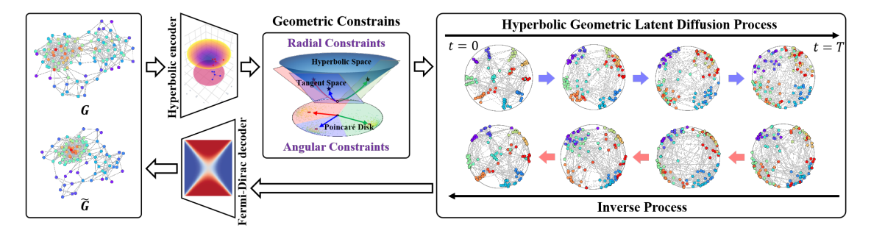
In continuous hyperbolic spaces, defining standard statistical moments such as mean and variance is mathematically complex due to the absence of a vector space structure. The natural geometric equivalent of the Euclidean average is the Fréchet mean (Chami et al., 2019). However, calculating the exact Fréchet mean is computationally intractable because it has no closed form solution. To compute variance and aggregate features efficiently, frameworks must leverage the Euclidean properties of the tangent space (Fu et al., 2024). Instead of solving the Fréchet mean directly on the manifold, the model projects the hyperbolic embeddings into the tangent space of a specific reference point using the logarithmic map. Once in this Euclidean domain, standard statistical operations such as attention-based neighborhood aggregation can be performed safely (Chami et al., 2019). Finally, the aggregated Euclidean results are projected back onto the hyperbolic manifold using the exponential map. By computing the variance and average locally in the tangent space, the model effectively approximates the Fréchet mean, ensuring stable optimization without distorting the geometric topology (Fu et al., 2024).
Figure 5. An illustration of the HypDiff architecture detailing the hyperbolic geometric autoencoder and the latent diffusion process (Fu et al., 2024).

Proposed Methodology

System Overview and Architecture
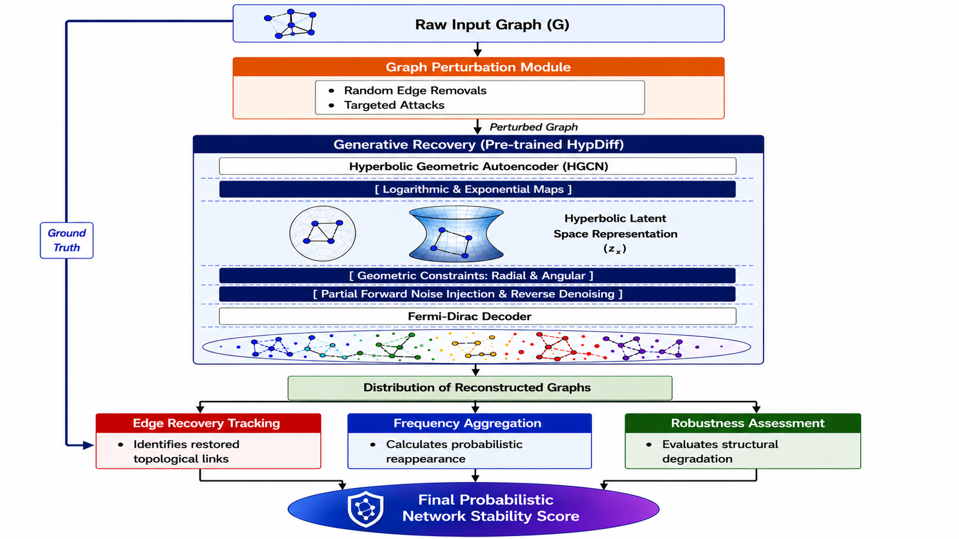
This chapter details the engineering pipeline for evaluating network stability using the HypDiff framework. The complete methodology is illustrated in the system architecture diagram below.
Figure 6. The proposed HypDiff pipeline architecture for network stability analysis.
As depicted in the architecture diagram, the proposed system operates through three primary sequential modules supported by a ground truth bypass connection for the final evaluation. First, the Graph Perturbation Module subjects the raw input graph to targeted attacks or random edge removals. The resulting perturbed graph serves as the direct input for the Generative Recovery Module, where it is processed through the pre-trained HypDiff model. Within this module, the graph is mapped into a continuous hyperbolic latent space representation $(z_{x})$ using a Hyperbolic Geometric Autoencoder, modified with partial forward noise, and restored via an anisotropic reverse denoising process and a Fermi-Dirac decoder. This process outputs a diverse distribution of reconstructed graphs. Finally, the Probabilistic Stability Scoring Module receives this generated distribution and compares it directly against the raw input graph, which bypasses the generative model to act as the absolute structural ground truth. Through parallel processes of edge recovery tracking and frequency aggregation, this final evaluation block calculates how frequently the removed edges reappear, outputting the final probabilistic network stability score.

Graph Perturbation Module
The Graph Perturbation Module serves as the initial active phase of the pipeline. It receives the raw input graph, mathematically defined as $G(V,E)$ with its corresponding adjacency matrix $A$. To systematically evaluate the network’s resilience, the module processes the input graph through two distinct and parameterized deletion methods. To comprehensively map the structural degradation, these removals are evaluated across a spectrum of incrementally increasing percentage thresholds (e.g., 10%, 20%, 30%), simulating increasingly aggressive topological disruptions:
- Random Edge Removals: Algorithmically, the system iterates over the edge set $E$ and removes edges based on a uniform probability distribution. The primary parameter controlling this process is the random removal fraction, denoted as $P_{rand}$. The system utilizes $P_{rand}$ to incrementally remove specific percentages of the total edges, outputting the randomly perturbed adjacency matrix $A'$.
- Targeted Attacks: In this method, the system evaluates and ranks edges based on the Degree Centrality of the two nodes they connect. The degree of a node, denoted as $k_{i}$, simply quantifies the total number of links involving that specific node. Specifically, for any given edge $e$ connecting node $i$ and node $j$, the system calculates an importance score based on their combined degrees, defined mathematically as $Score(e)=k_{i}×k_{j}$. The controlling parameter for this process is the targeted removal fraction, denoted as $P_{target}$. Once all edges are scored, the module sorts the entire edge set in descending order. The system then deterministically deletes the top $P_{target}$ percent of these links, strictly preserving the original node.
To ensure statistical significance and prevent biased results from a single random sampling, the perturbation module is designed to operate iteratively. For any given degradation threshold (whether utilizing random removals or targeted attacks), the module repeats the masking process for $N$ independent iterations. Instead of outputting a single modified graph, this mechanism generates a batch of perturbed adjacency matrices $({A^{'}}_{1,}{A^{'}}_{2},…,{A'}_{N})$. This batch is subsequently passed to the generative recovery module, ensuring that the final evaluation reflects true geometric robustness rather than stochastic noise.

Generative Recovery Module
The Generative Recovery Module processes the Perturbed Graph, denoted as $G'(V,E')$, through a strict sequence of operations using the pre-trained HypDiff model. To explicitly define the reconstruction process, the module operates through a strict pipeline of three distinct algorithms to probabilistically restore the missing edges:
- Hyperbolic Geometric Encoding Algorithm
The module processes the perturbed adjacency matrix $A'$ through a hyperbolic geometric autoencoder based on the Hyperbolic Graph Convolutional Neural Networks (HGCN). Utilizing logarithmic and exponential maps, the system performs the neural network operations within the Euclidean tangent space. This encoding phase preserves the inherent geometric properties and directly outputs the continuous hyperbolic latent space representation $(z_{x})$.

- Anisotropic Reverse Denoising Algorithm
Once the perturbed graph is mapped, the system enforces radial and angular geometric constraints. Following the injection of partial forward noise, the model executes the anisotropic reverse denoising algorithm. This algorithmic process iteratively cleans the noise along specific directional vectors to probabilistically reconstruct and restore the missing topological links within the latent space.
- Fermi-Dirac Decoding Algorithm
In the final step of the recovery module, the system passes the cleaned continuous hyperbolic latent representations through a Fermi-Dirac Decoder. This decoding algorithm directly computes the exact connection probabilities between nodes to output the discrete reconstructed adjacency matrix. Repeated executions of this entire algorithmic pipeline on the exact same perturbed graph yield slightly different structural solutions, generating a Distribution of Reconstructed Graphs.

Probabilistic Stability Scoring Module
The Probabilistic Stability Scoring Module is the final evaluation stage of the system pipeline. It receives the Distribution of Reconstructed Graphs generated by the recovery module and compares them directly against the absolute structural ground truth provided by the raw input graph. The module calculates the final stability metric through a sequence of algorithmic steps:
- Edge Recovery Tracking:
To evaluate stability, the system must first isolate the exact topological structures destroyed during the perturbation phase. The module receives the original adjacency matrix $A$ and the perturbed adjacency matrix $A'$. It computes the difference between these matrices to isolate the exact set of removed edges, denoted as $E_{removed}$. This set acts as the target features for the subsequent recovery evaluation.
- Frequency Aggregation:
To algorithmically measure the success of the reconstruction process, the system evaluates the generated distribution consisting of $M$ distinct reconstructed adjacency matrices, denoted as $\{A_{rec}^{(1)},A_{rec}^{(2)},…,A_{rec}^{(M)}\}$, which are directly derived from the $N$ iterative perturbation cycles. For each targeted edge$e=(i,j)$ in the set $E_{removed}$, the algorithm calculates its probabilistic reappearance across the entire generated distribution. The recovery probability for a specific edge is computed using the following aggregation formula:
$$P_{recovery}(e)=\frac{1}{M}\sum_{m=1}^{M}{A_{rec}^{\left(m\right)}(i,j)}.$$
This algorithmic formulation mathematically quantifies the exact frequency at which the generative model successfully restored a destroyed connection across all $N$ independent perturbation iterations.
- Robustness Assessment and Final Score
In the final step, the system aggregates the individual edge recovery probabilities to compute a single comprehensive metric. By explicitly tracking this recovery success across the entire iterative batch, the system ensures that the evaluation is statistically significant and robust against random sampling noise. The Final Probabilistic Network Stability Score, denoted as $S_{stability}$, is calculated as the arithmetic mean of the recovery probabilities for all targeted edges:
$$S_{stability}=\frac{1}{\left|E_{removed}\right|}\sum_{e∈E_{removed}}{P_{recovery}(e).}$$
This final score provides a quantified, uncertainty aware measure of the network topology resilience. A high score indicates that the underlying hierarchical structure contains sufficient geometric information for the algorithm to confidently restore the missing links across multiple corrupted states, implying a highly stable network.

Evaluation and Verification Plan

Success Metrics and Criteria
- Probabilistic Network Stability Score: This is the primary metric used to evaluate Logical Metric Degradation and Comparative Advantage. The framework will be considered successful if the $S_{stability}$ score remains consistently higher than baseline discrete diffusion models under severe attack thresholds, proving that the hyperbolic latent space provides a mathematically superior bound for geometric recovery under dynamic stress
- Graph Topological Metrics: To ensure Generative Consistency, it is necessary to verify that the generated graphs maintain the macroscopic structural integrity of the original networks. The framework will measure the Maximum Mean Discrepancy (MMD) distance, specifically focusing on Degree, Cluster, and Spectre metrics. A lower MMD score will quantitatively prove that the physical topology of the network was preserved despite the perturbations.
- Fidelity and Diversity Metrics: Further validating Generative Consistency, the system will use precision-recall $(F1_{pr})$ and density-coverage $(F1_{dc})$ scores. These metrics are critical for proving that the variance in the generated distribution reflects true structural uncertainty. High F1 scores will serve as empirical proof that the system did not suffer from generative failures like “mode collapse”, which would artificially inflate the stability score with repetitive, identical graphs.

Evaluation Datasets
To comprehensively evaluate the framework's structural robustness and generative recovery capabilities across diverse network topologies, the system will be tested on a combination of synthetic and real-world datasets.

Synthetic Datasets
The evaluation will utilize standard graph theoretical models to test the framework on controlled, single-nature topologies:
- Stochastic Block Model (SBM): Utilized to evaluate the system's ability to preserve complex, modular community structures under perturbation.
- Barabási-Albert (BA): Utilized to assess performance on scale-free networks, specifically testing the preservation of highly connected topological “hubs” during targeted attacks.

Real-World Datasets
To validate the framework's practical applicability and its ability to handle natural structural anisotropy, experiments will be conducted on diverse real-world networks commonly used as benchmarks for graph generation tasks:
- Social Networks (IMDB-B): A social network dataset symbolizing the co-starring dynamics of actors. This will be used to test the model's resilience on graphs with distinct human-centric local clustering.
- Biological Protein Maps (PROTEINS): A biological network where nodes represent amino acids and edges denote a proximity of less than 6 Angstroms. This dataset will be utilized to evaluate the framework's stability on highly connected biological topologies.

Planned Experiments and Expected Results
Test Category | Experiment Description | Purpose | Expected Insight
Comparative Stability | Compare the $S_{stability}$ score against deterministic metrics (Algebraic Connectivity, Betweenness Centrality) on networks subjected to targeted attacks. | Demonstrate the comparative advantage of the probabilistic framework. | We expect deterministic metrics to show abrupt, unreliable jumps in value, whereas the $S_{stability}$ distribution will smoothly and accurately reflect the true system resilience.
Generative Baseline Comparison | Compare the edge reconstruction accuracy of the HypDiff Generative Recovery Module against Euclidean-based graph diffusion baselines (e.g., GDSS, DiGress) under identical perturbation thresholds. | To empirically prove that the hyperbolic latent space and anisotropic diffusion prevent geometric distortion and provide superior structural recovery compared to standard Euclidean models. | We expect HypDiff to consistently achieve higher edge recovery rates, proving its geometric superiority.
Robustness Degradation | Systematically stress-test networks by increasing the percentage thresholds for Random Edge Removals $(P_{rand})$ and Targeted Attacks $(P_{target})$(e.g., 10%, 20%, 30%, 40%, 50%) | Validate the core perturbation and scoring modules across a spectrum of damage. | We expect the $S_{stability}$ score to plot a smooth downward degradation curve. We hypothesize that $P_{target}$(targeted attacks) will cause a faster degradation than $P_{rand}$ (random removals).
Generative Consistency Verification | Apply severe perturbations (e.g., >30% removal), run the Generative Recovery Module, and evaluate the output distribution using MMD and F1 scores. | Verify that the variance in the reconstructed graphs reflects true structural uncertainty rather than random algorithmic noise. | We expect the model to maintain strong MMD and F1 scores under heavy damage. This will prove the system avoids mode collapse, ensuring the calculated $S_{stability}$ score is a reliable and accurate measurement of network resilience.
Hyperparameter Calibration | Perform a Grid Search optimization on a validation subset to determine the optimal values for the Fermi-Dirac Hyperparameters $(r,t)$ and perturbation thresholds. | To mitigate metric sensitivity and establish a stable, unbiased baseline for the $S_{stability}$ score before executing the main degradation experiments. | We expect to identify a specific configuration of hyperparameters that maximizes generative stability and minimizes random scoring fluctuations.

Formal Software Testing Strategy
Test Type | Target Component | Test Description and Execution | Expected Result
Unit Test | Graph Perturbation Module | Input a standard graph and execute the Random Edge Removal and Targeted Attack methods using fixed parameter thresholds (e.g., $P_{rand}=20\%$and $P_{target}=20\%$) | The module outputs a perturbed adjacency matrix with exactly 20% of the relevant edges removed and the original node set remains structurally intact.
Unit Test | Hyperbolic Autoencoder | Pass a perturbed graph through the HGCN encoder and Fermi-Dirac decoder without adding diffusion noise. | The model encodes and decodes the graph without dimension mismatch errors. The output adjacency matrix shape exactly matches the input, and the latent node embeddings contain no invalid or NaN values.
Unit Test | Stability Scoring Module | Input a mock “Original Graph” and a mock “Reconstructed Graph” with known differences. | The module correctly identifies the exact set of removed edges $(E_{removed})$ and accurately calculates the mean recovery frequency $(S_{stability})$ as a continuous float between 0 and 1.
Integration Test | Pipeline Data Flow | Run a small subset of the PROTEINS dataset through the entire sequence: Perturbation $→$ Generative Recovery $→$ Scoring. | The data structures pass smoothly between modules without shape mismatch errors and the pipeline outputs a continuous probabilistic score.
System Test | End-to-End Execution | Execute the full degradation experiment (e.g., 10% to 50% removal) on the complete IMDB-B dataset. | The full execution completes seamlessly without crashes, and the system successfully plots the expected downward degradation curve of the $S_{stability}$ score.
Performance Test | Computational Efficiency | Run the full Generative Recovery Module (1000 diffusion timesteps) on the IMDB-B dataset and monitor hardware resource consumption. | The system runs highly efficiently, executing in under 15 seconds and utilizing less than 3GB of VRAM.

Diffusion Efficiency Analysis
To successfully pass the Performance Test defined in Table 2, the system relies on the computational efficiency of the HypDiff architecture. Traditional discrete diffusion models (like EDGE and GraphGDP) apply diffusion directly to large adjacency matrices, requiring approximately 6000 MB of GPU memory (VRAM). In contrast, by compressing the graph into a low-dimensional hyperbolic latent space, the proposed Generative Recovery Module reduces the space complexity to $O(smd)$. Empirical benchmarks demonstrate that executing 1000 diffusion timesteps on the IMDB-B dataset requires only 2519 MB of VRAM and an average of 11.2 seconds. This lightweight geometric prior mathematically guarantees that the evaluation framework is computationally feasible for Phase B, avoiding system crashes without requiring enterprise-grade hardware.

System Infrastructure and Project Roadmap

System Requirements
Functional Requirements
- Graph Ingestion and Preprocessing: The system shall receive raw complex network datasets as input and convert them into standard discrete adjacency matrices for processing.
- Iterative Edge Removal (Perturbation): The system shall execute a predefined number of perturbation iterations $(N)$. In each iteration, the system shall actively remove a specific fraction of edges from the network.
- Hyperbolic Geometric Encoding: The system shall process the damaged graphs from each iteration and map them into a continuous hyperbolic latent space using HGCN.
- Generative Edge Reconstruction: The system shall apply an anisotropic reverse diffusion process to the latent representations, attempting to predict and computationally reconstruct the exact topological links that were removed.
- Probabilistic Stability Scoring: The system shall track the reconstruction success across all $N$ iterations and output a final numerical stability score $(S_{stability})$ based on the aggregated recovery frequency of the removed edges.
Non-Functional Requirements
- Scalability: The system must efficiently handle complex scale-free networks by embedding them into hyperbolic space, actively avoiding the geometric distortion caused by Euclidean spaces.
- Robustness: The anisotropic diffusion process must maintain structural stability and prevent the signal-to-noise ratio from rapidly decaying under the injected topological noise.
- Computational Efficiency: The system must perform standard statistical operations locally within the Euclidean tangent space utilizing logarithmic and exponential maps.
- Performance and Hardware Limits: The generative recovery module must execute 1000 diffusion timesteps in under 15 seconds and utilize less than 3GB of GPU VRAM to ensure computational feasibility.
- Reproducibility: The system must log all perturbation parameters and utilize fixed random seeds to ensure that repeated executions yield consistent and reliable stability scores.
- Modularity: The software pipeline must be modularly structured, ensuring that the perturbation module and the scoring module can be updated, expanded, or replaced without requiring modifications to the core generative diffusion engine.

Expected Challenges
- Architectural Adaptation: Adapting the generative HypDiff framework to measure stability requires balancing sampling stability to reconstruct removed edges without overwriting the remaining structure.
- Geometric Instability in Hyperbolic Embeddings: Targeted or random edge disruptions can drastically warp the network's underlying hierarchical geometry, causing unpredictable coordinate shifts during HGCN encoding.
- Calibration and Sensitivity of the Network Resilience Score: The newly proposed $S_{stbility}$ metric is highly sensitive to baseline graph density and Fermi-Dirac hyperparameters, which may yield unstable or skewed resilience scores.
- Computational and Run-Time Overhead: The combined use of hyperbolic K-Means clustering, repeated tangent plane projections and running $M$ reverse denoising iterations substantially increases computational complexity.
- Controlling Generative Hallucinations: The decoder may generate topologically plausible but historically non-existent links, creating false positives that could artificially inflate the final network stability score

Future Work Plan and Project Roadmap
The project lifecycle is structured into distinct stages, progressing from theoretical mathematical foundations to practical software verification. Following the geometric and architectural design presented in Phase A, the roadmap for Phase B focuses on the translation of these continuous-time diffusion concepts into a fully operational and deployable evaluation framework. The work plan consists of the following primary development stages:
- Theoretical Design: Formulation of the mathematical methodology for the stability framework and completion of the formal system architecture and testing plan.
- Pipeline Implementation: Development of the Python/PyTorch codebase, focusing on building the Graph Perturbation Module, integrating the pre-trained HypDiff autoencoder, and implementing the Probabilistic Stability Scoring module.
- Experimental Validation: Execution of the formal testing strategy on real-world datasets to empirically calibrate noise, calculate the $S_{stability}$ metric, and plot degradation curves.
- Optimization and Final Defense: Analysis of the empirical results, optimization of hardware execution times (VRAM and runtime), and documentation of the final findings for the final project report.

Ai Tools Usage
Phase | Tool | Prompt Used | Purpose
Literature Review | NotebookLM | “Summarize the mathematical formulations and geometric constraints of the HypDiff latent diffusion model from the uploaded source.” | Analyzing complex mathematical research papers and extracting the core non-Euclidean graph embedding formulas.
Mathematical Background | Perplexity | “How do hyperbolic graph neural networks utilize the Fermi-Dirac decoder to calculate connection probabilities?” | Searching the web for real-time academic explanations and cross-referencing geometric machine learning concepts.
System Design | Gemini | “What are the expected algorithmic challenges when adapting a generative HypDiff model to perform guided edge reconstruction instead of pure generation?” | Brainstorming and identifying practical software engineering bottlenecks for Phase B.
Algorithmic Logic | Gemini | “Explain the geometric instability in hyperbolic embeddings when targeted edge disruptions occur.” | Refining the definitions of mathematical risks associated with the continuous-time pipeline.
Writing and Editing | Gemini/ NotebookLM | “Refine this text for academic tone: 'The project uses a generative model to find the true stability of the network.” | Improving the clarity and professional tone of the documentation.

References
Artime, O., Grassia, M., De Domenico, M., Gleeson, J. P., Makse, H. A., Mangioni, G., ... & Radicchi, F. (2024). Robustness and resilience of complex networks. Nature Reviews Physics, 6(2), 114-131.
Chami, I., Ying, Z., Ré, C., & Leskovec, J. (2019). Hyperbolic graph convolutional neural networks. Advances in neural information processing systems, 32.‏
Elhag, A. A., Corso, G., Stärk, H., & Bronstein, M. M. (2022, April). Graph anisotropic diffusion for molecules. In ICLR2022 Machine Learning for Drug Discovery
Ellens, W., & Kooij, R. E. (2013). Graph measures and network robustness. arXiv preprint arXiv:1311.5064.‏
Fu, X., Gao, Y., Wei, Y., Sun, Q., Peng, H., Li, J., & Li, X. (2024). Hyperbolic geometric latent diffusion model for graph generation. arXiv preprint arXiv:2405.03188.
Ho, J., Jain, A., & Abbeel, P. (2020). Denoising diffusion probabilistic models. Advances in neural information processing systems, 33, 6840-6851.
Huang, H., Sun, L., Du, B., Fu, Y., & Lv, W. (2022, November). Graphgdp: Generative diffusion processes for permutation invariant graph generation. In 2022 IEEE International Conference on Data Mining (ICDM) (pp. 201-210). IEEE.
Jo, J., Lee, S., & Hwang, S. J. (2022, June). Score-based generative modeling of graphs via the system of stochastic differential equations. In International conference on machine learning (pp. 10362-10383). PMLR.‏
Nickel, M., & Kiela, D. (2017). Poincaré embeddings for learning hierarchical representations. Advances in neural information processing systems, 30.
Papadopoulos, F., Kitsak, M., Serrano, M. Á., Boguná, M., & Krioukov, D. (2012). Popularity versus similarity in growing networks. Nature, 489(7417), 537-540.
Vignac, C., Krawczuk, I., Siraudin, A., Wang, B., Cevher, V., & Frossard, P. (2022). Digress: Discrete denoising diffusion for graph generation. arXiv preprint arXiv:2209.14734.
Yang, R., Yang, Y., Zhou, F., & Sun, Q. (2023). Directional diffusion models for graph representation learning. Advances in neural information processing systems, 36, 32720-32731.

